Step1-> create react project and add Dockerfile in root folder.

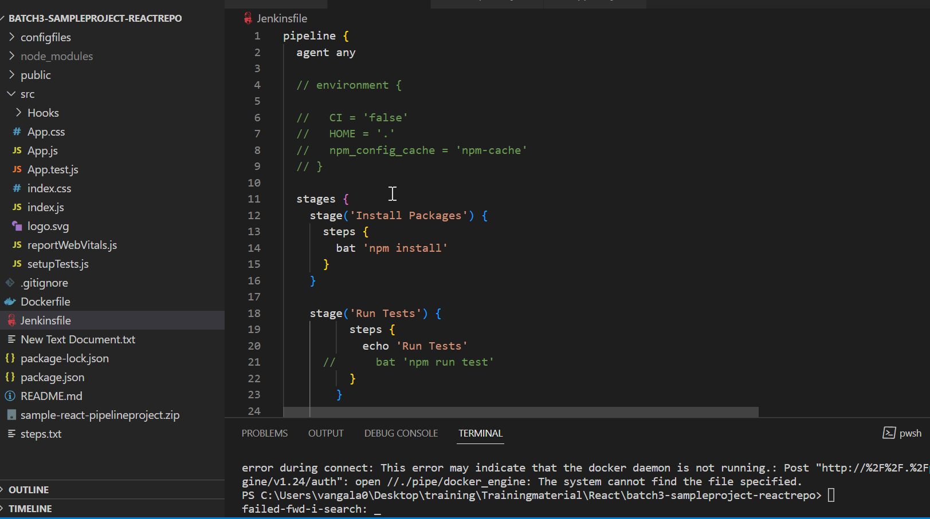

Step2-> Write following configuration into Dockerfile

FROM docker.repository.esi.adp.com/clientcentral/node:12.7.0

WORKDIR /app

COPY package.json .

#RUN npm i

#RUN npm install

COPY . .

CMD ["npm", "start"]

EXPOSE 3000

Need to pull node image from repository, specifying foldername where project locate din container ,copy package.json file , command to run project , specify port number where project is exposed.

If you run num install in VM/host this step is not needed so it it comment